|  |
| --- |
| FORENOON SESSION DETAILS |
| FORENOON SESSION DETAILS: Image of session C:\Users\Envision2\Desktop\New folder\format234.png |

DAILY ASSESSMENT REPORT

|  |  |  |  |
| --- | --- | --- | --- |
| Date: | 26 May 2020 | Name: | Rachana C Hulikatti |
| Course: | DIGITAL SIGNAL PROCESSING | USN: | 4AL17EC108 |
| Topic: | * Fourier Series & Gibbs Phenomena using Python * Fourier Transform * Fourier Transform   Derivatives   * Fourier Transform and   Convolution   * Intuition of Fourier Transform and Laplace   Transform   * Laplace Transform of First order * Implementation of Laplace   Transform using Matlab   * Applications of Z-Transform * Find the Z-Transform of sequence using Matlab | Semester & Section: | 6th sem & B sec |
| Github: |  |  |  |

Report:

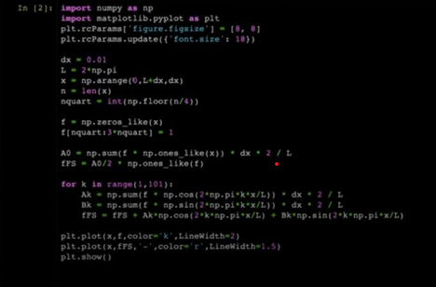

Applications:

-

Sampled systems

Inputs

and outputs are related by difference equations and Z

-

transform techniques are

used to solve those difference equations.

VOICE

TRANSMISSION:

To band

-

limit the signal and filter noise from the signal.

Calculation of a signal to control a system

.

-

Z transform:

•

The above picture is a basic example of Z

-

Transform using Matlab.

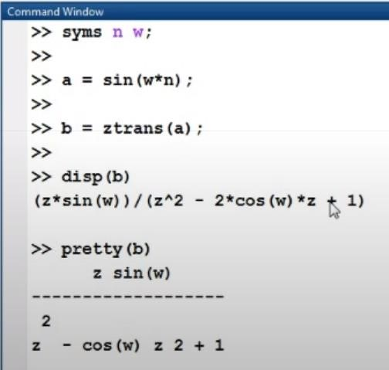

|  |  |  |  |
| --- | --- | --- | --- |
| Date: | 26 May 2020 | Name: | Rachana C Hulikatti |
| Course: | The Python Mega Course | USN: | 4AL17EC108 |
| Topic: | Application 4: Build a Personal Website with Python and Flask | Semester & Section: | 6th sem & B sec |

|  |
| --- |
| AFTERNOON SESSION DETAILS |
| Image of session:                                      C:\Users\Envision2\Desktop\format234.png |

Report

–

Report can be typed or hand written for up to two pages.

Build personal website :with flask

:

We have

learnt to build our Personal website using Python.

It shows how to render links from one page to another.

It

also includes

HTML format for making good visuals.

Also shows how to create virtual environment to run the app.

T

his

course

helped in putting

our website into global domain as

well.

There is scope for further improvement in the current website.

T

he

below shown are some images of personal website built by me.